FUNDING TECHNOLOGY
  - ASSIGNMENT SHEET
Place all responses and research here

SHARE
After watching the webinar on writing successful grants, share one tip that you learned. PASTE TIP HERE  Before completing this module, the idea of grant writing was a confusing and abstract idea. To be honest, I’ve always known the phrase “grant writing” but until now I never really thought about the process. I know it sounds odd, but I never thought about grants in terms of actually “writing” a grant. This webinar and the other resources have been rather eye-opening.  I think a great tip that I learned was to be positive. This might seem self-explanatory to some, but it wasn’t to me. Quite often I think of schools lacking resources. Because we frame the discussion in terms of what the school is lacking one might think that a school is requesting funds out of desperation. This certainly isn’t positive. For generations teachers have made do with what they have in order to provide their students with the best education possible. For me, the challenge would be to change the discussion away from what the student’s lack, to a discussion about the possibility of a greater things; the potential that each student has that this grant might help to unlock.  My questions are a bit more nuts and bolts than anything else. How much time is this going to take? I realize that grants have submission deadlines, but how long ahead of time should I form my team before we submit the grant? Often times the presenter referred to “allowing time”, but how much time do we need to plan for? What does the timeline look like and how often is the team meeting to discuss the process?  All in all, this process seems very intimidating to me. However, considering that before this module I knew next to nothing, I’m feeling a lot better. | Click here to share with classmates

EXPLORE
Explore the sites linked here to find grants that would work for your grade, subject, location, and need. Share 5 grants with links below. Share on the group Linoit page with your classmates
James Madison Memorial Fellowship Foundation
American Immigration Law Foundation's Teacher Grant Program
Changing America: The Emancipation Proclamation, 1863 and the March on Washington, 1963
Dust, Drought, and Dreams Gone By
C-SPAN StudentCam

REFLECT/SHARE
Of the tips learned, which tips did you find to be the most beneficial to the grant writing process?  The more I learn about the grant writing process the more daunting it seems to be. So much data, so much time, so much to do. While many of the resources presented were designed to make the process seem easier, in the end I felt more intimidated than I did in the beginning! However, the most beneficial tip that I read amongst all of them had to do with collaboration/forming a grant writing team. While the authors were quick to point out that too many team members actually trying to write the grant proposal can be a bad idea, forming a team of teachers, parents, and community members that each bring a different set of skills to the process can be beneficial.  I think I’m more of an idea guy. I’m not a great writer, I’m not great with numbers, and I don’t network well. However, I know some folks in the English department who would be perfectly suited to articulate our team’s ideas to a grant reader. Parents and school board members could help us with budgets and put us in contact with businesses in our community that might be able to lend a helping hand.  I’m curious about where to begin. Are there particular resources that already exist in my school that can help me with the process? It seems to be that starting from square one would be so time consuming that the process would never be compete. Furthermore, how much time should one allow for grant writing? | Click here to reflect and share

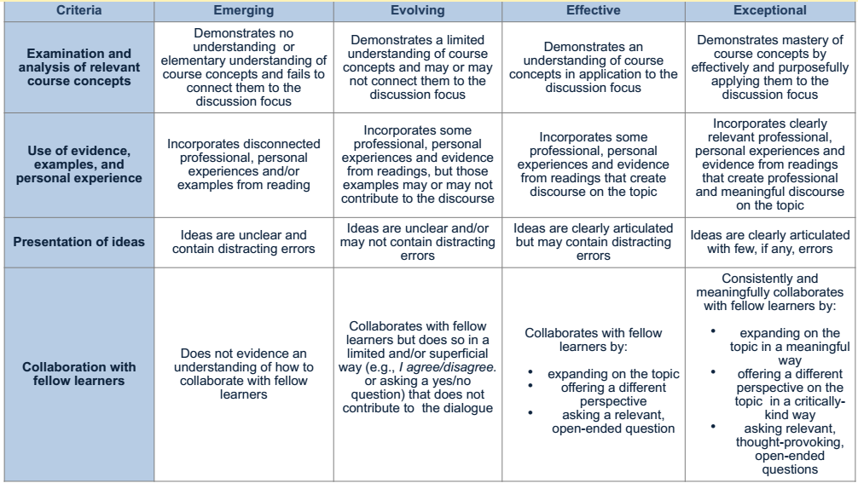

SHARE
Share at least one of the following. If you already found a grant that fits into this category, re-share the grant here.
Local Grant Example: Gheens Foundation Inc.
Local Business Grant Example: Brown Forman
Grants Listed on the State Department of Education: 2014 Instructional Transition Initiative

SHOW
Now that you have a good idea where to find grants and what to include in a grant proposal, show your knowledge by explaining your grant proposal idea. Place all of your information in the Funding assignment sheet attached here.
Step 1: Brown-Forman Grant:
http://www.brown-forman.com/responsibility/relations/apply.aspx
Step 2: What is your proposal idea?
I would request funds for a class set of student video cameras that students could use to create short documentaries about the rich history of Louisville, KY. Student films will examine historical figures, buildings, and events that have shaped Louisville into the city it is today.

Step 3: How will you make your proposals upbeat, positive, and interesting?
Brown-Forman provides grants for several areas including education and environmental protection, which includes historical preservation. The grants strive to impact Louisville and the surrounding areas. My proposal would focus on all three of these aspects. As a history teacher, I take great pride in teaching about the history of the United States. Unfortunately, meeting deadlines and staying on track with curriculum maps sometimes mean that a great deal of valuable history is left out of the classroom. This includes our local history. Louisville, Kentucky is a city rich in history. From the first settlers arriving shortly after the revolution, to its time as a launching point for western migration, to its time as home to the “Greatest of All-Time”, Louisville has a history that needs to be preserved.
Because of limited class time, it is necessary to allow students opportunities beyond the schoolhouse to learn about our local history. The message of my grant would be to let the business known that by providing funds for the appropriate tools, students will be able to learn about our hometown in a new and exciting way. By sparking an interest in local history, students will take pride in their city. By exciting students about local history at such a young age it is likely that they will work to preserve our city’s heritage philanthropic work when they become the civic, business, and community leaders of tomorrow.

